Press Release

Clever³ – simpler. More reliable. More intelligent.
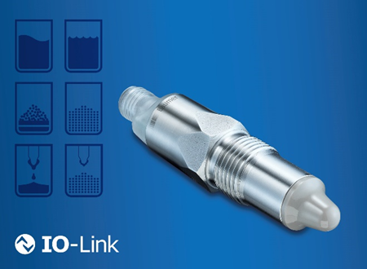
(29.04.2020) The original puts you one step ahead – point level detection has never been this easy and reliable. Thanks to the new level switch PL20, the CleverLevel series from Baumer now offers more possibilities for detecting point levels. CleverLevel reliably detects every type of medium, whether liquid, pasty, viscous, or solid, and is therefore the solution for a variety of applications for which standard vibrating forks are used today. One of its major advantages is the fact that it does not have to be parameterized to a medium as before but flexibly adapts to the medium at hand. This way, even adhesions such as those that frequently occur with pasty materials can be reliably masked. With its optional 4 … 20 mA analog signal, the PL20 offers a number of additional advantages and true added value for increased efficiency of your production process.
Intelligent design and functions
The food and beverage production sector is distinguished by increasingly individual customer requirements. Conventional measurement systems are unable to cope with the different media characteristics involved. The new level switch CleverLevel PL20 makes processes more flexible and eliminates additional efforts – because it no longer matters what is in the tank. The PL20 level switch offers true added value, especially when it comes to applications in the food production sector with changing recipes or batch production. The self-learning sensor automatically adjusts to the different media. This ensures maximum flexibility with minimum set-up times. In addition, thanks to its compact design and low installation depth, it has only a minor impact on the process and thus ensures maximum food safety.
Robust, durable, and safe for food use
Even adhesions such as those that occur with pasty materials and electrostatic charging do not affect the performance of the sensor. In such cases as well, the level switch adjusts the switching level without any type of parameterization, minimizing downtimes that may be caused by faulty switching. With an additional optional 4 … 20 mA analog output, the PL20 can help differentiate the media within the process or evaluate the cleaning process. What is more, the graphic evaluation of the measurement results with the help of the FlexProgrammer ensures a transparent process. In addition, the sensor can be easily and quickly integrated in already existing systems via the analog interface. At the same time, the large selection of process connections and adapters allows the flexible and easy integration of the sensor.
More information available at:
www.baumer.com/cleverlevel
Baumer Group
The Baumer Group is an internationally leading manufacturer of sensors, encoders, measuring instruments and automated image-processing components. Baumer combines innovative technology and customer oriented service into intelligent solutions for factory and process automation and offers a uniquely wide range of related products and technologies. The family-owned company has around 2,700 employees with manufacturing facilities, sales offices and agents in 38 offices and 19 countries, always close to the customer. With consistently high quality standards worldwide and a huge potential for innovation, Baumer brings their customers critical advantages and measurable added value across many industries. For more information, visit www.baumer.com.
Press contact:  Florin Kraft  Baumer Group  Phone +49 (0) 7771 6474 1209  Fax +41 (0)52 7281144  FKraft@baumer.com  www.baumer.com | Company contact global:  Baumer Group  Phone +41 (0)52 728 11 22  Fax +41 (0)52 728 11 44  sales@baumer.com  www.baumer.com

